Calculator Snooker
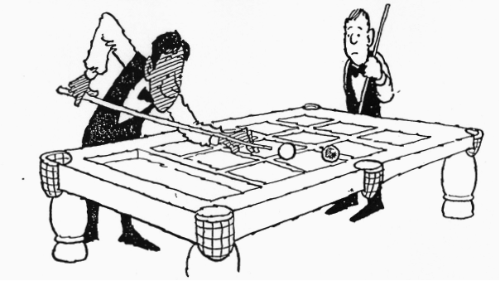
A Game for 2 players

Player A enters any two-digit number. B takes a shot by performing a multiplication sum. To pot a ball, the first digit on the answer must be the same as the value of a ball.
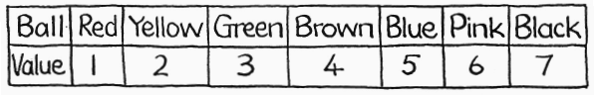

Otherwise, the rules are similar to real Snooker. There are 10 (or 15) reds and one of each of the six colours. A player must score in the order red, colour, red, colour, and so on, until all the reds have gone. (Note that the colours are replaced but the reds are not)
When the last red has gone, the colours are potted in order and are not replaced.

